United Nations General Assembly Voting Data Analysis

History
Last year I worked with Fiona and Alice to develop some global consensus dashboards. The project involved the ingestion of UN voting data and calculation of voting coincidence by country. The project evolved and included the addition of other data elements, new calculations and additional visuals. Most recently, I’ve been working on adding analysis using the Index of Voting Cohesion and vocabulary features.

Data model
Raw data from numerous sources is processed in Python and extracted in a Tableau Hyper file format with the following relationships. Some information is precomputed, but wherever possible the computations are pushed to Tableau to allow for flexible aggregation levels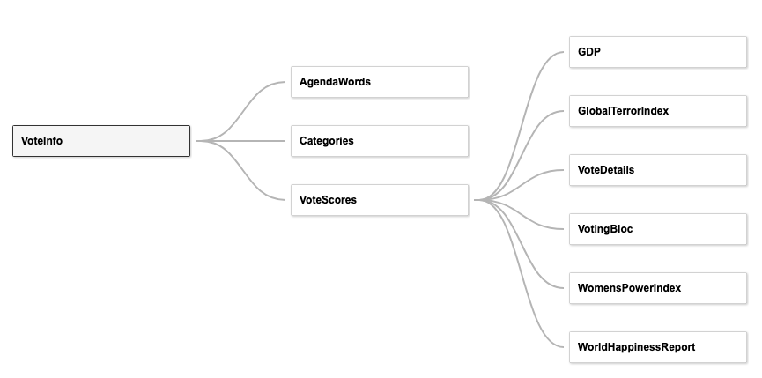

Dashboards
IVC - The main Index of Voting Cohesion dashboard allows for user selection of voting blocs, filtering on resolution action date, sub level category, IVC levels and agenda categories. The average yearly IVC value is displayed in the time-series line chart and the pull period average by top / sub level category is shown in the bar chart. The lower table splits out aggregate directional voting details by category.

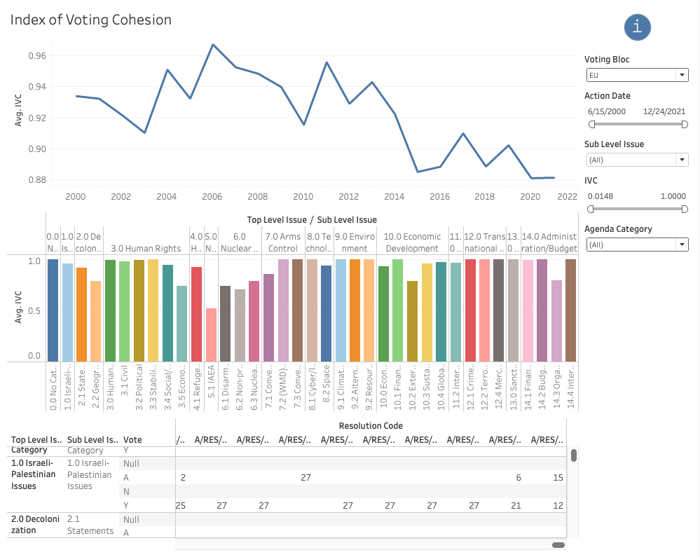

The lower-level detail section includes tool tip visualizations that decompose which bloc members participated in voting direction. For example, EU IVC for nuclear related agenda category resolutions have decreased over time. Hovering over the vote count will show the details of which country participated, sorted in descending order by GDP.

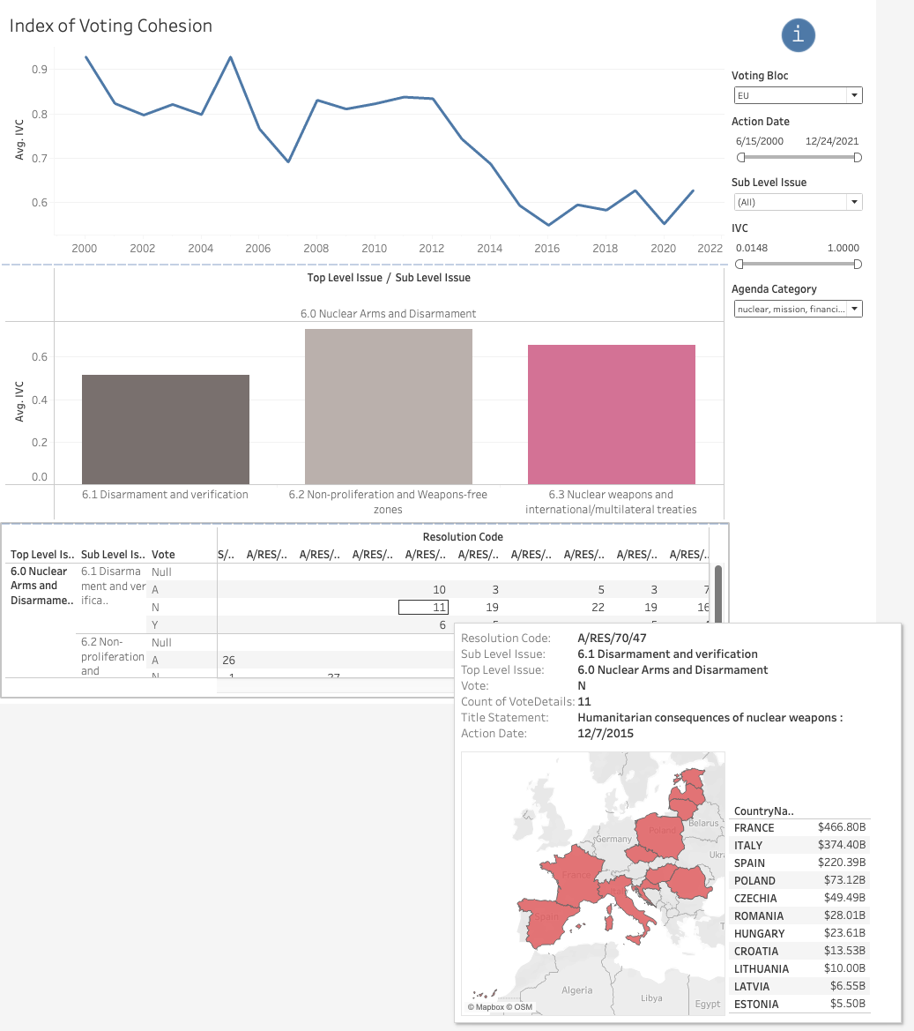

Alternate IVC - Below is an alternate view of IVC data that incorporates an average period IVC heatmap over voting bloc and top-level category. Clicking on a cell in the heatmap will apply the row’s top-level issuer filter to the lower time-series line chart. I find this helpful to tease out low IVC both within and across blocs.

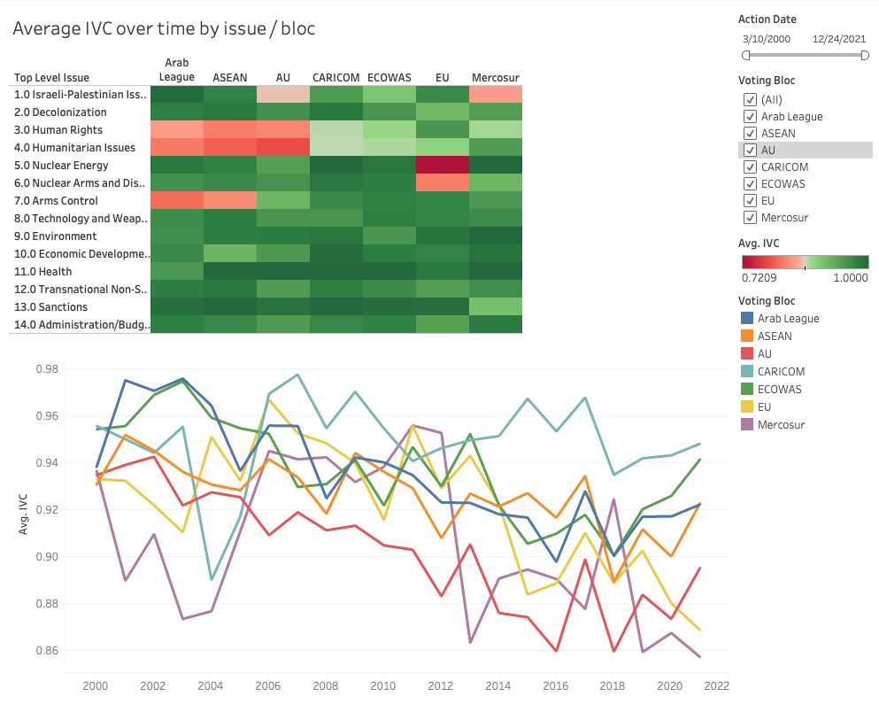

Vocabulary Analysis - I have recently been experimenting with vocabulary analysis. Sentiment analysis was performed on agenda title text in Python with mixed results. As part of this effort, I’ve included word tokens from agenda title text that relate back to resolutions in the data export. Below is a dashboard that highlights the most common word occurrences by top-level category over time.

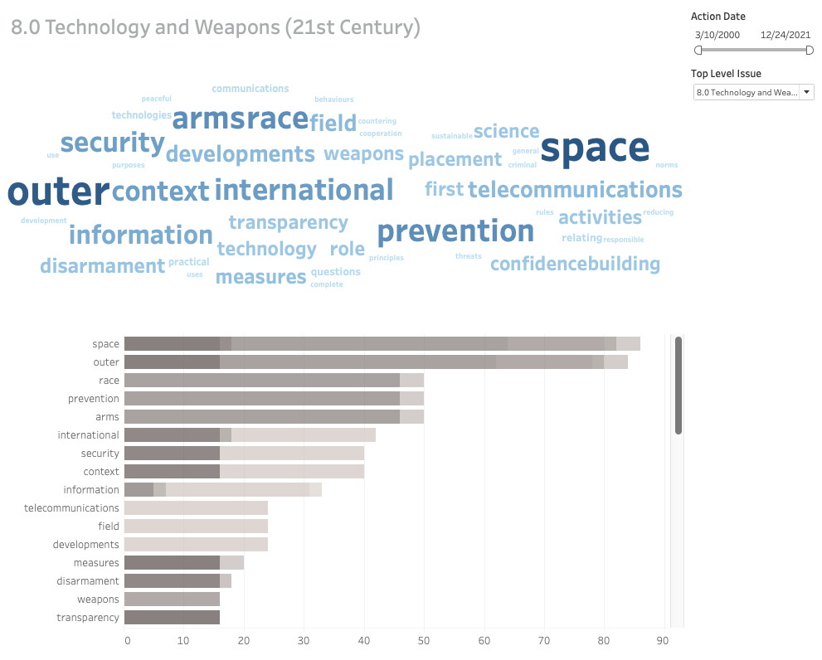

Global Consensus – This is the original dashboard that focused on analyzing voting coincidence by country. The voting coincidence percentage represents the amount that other countries vote directionally aligned with a given coincidence country. What I could consider a similar measure to the Index of Voting Cohesion, but single country versus everyone else instead of relative agreement within bloc. I could see this being extended to allow comparison of a coincidence country to not only other individual countries, but also voting blocs.



